Use case

Use Case Diagram :-

● Use cases represent system functionality from the user`s perspective.

● Use case diagrams describe who will use the system and in what ways the user expects to interact with the system.

● Use case diagrams represent the interactions between use cases and actors.

● Use case diagram represents the interactions between system, external systems, and users.

Use case scenario:-

● a use case scenario represents the sequence of events along with other information that relates to this use case.

● A typical use case specification template includes the following information:-

-Primary Actor

-Secondary Actor (if exist)

-Include use case (if exist)

-Purpose

-Pre and post condition

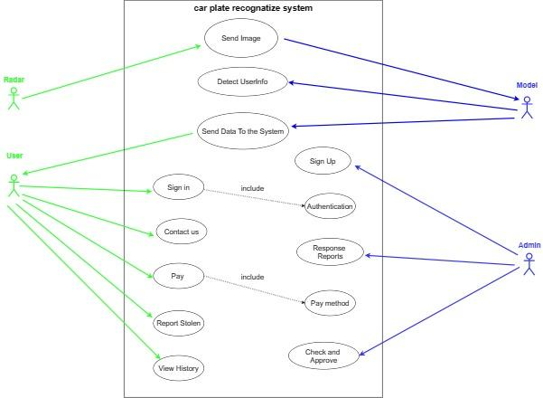

A sequence diagram is a type of interaction diagram because it describes how -and

in what order- a group of objects works together. These diagrams are used by

software developers and business professionals to understand requirements for a

new system or to document an existing process

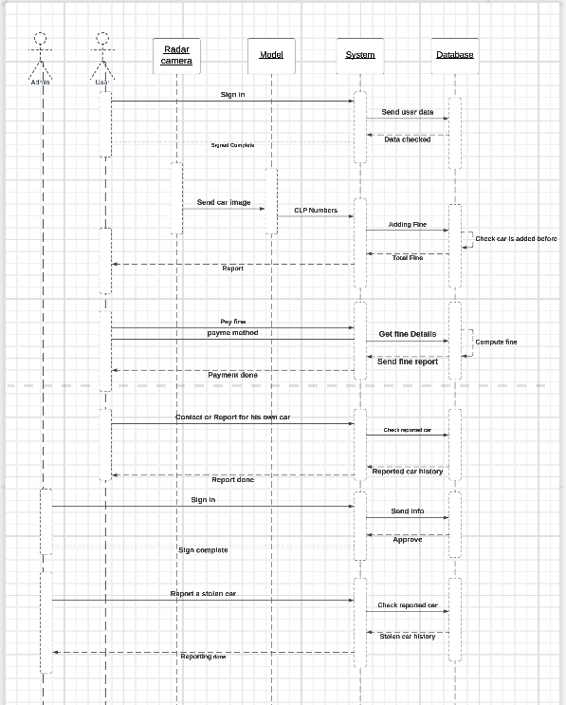

-User can enter the system by signing in with his information as he will send the info to the system then the system sends it to the database to check if this data is true or not and whether this user is in the system or not.

-Radar Camera sends the photo that taken from the gate to the model, the model will be able to get the photo in addition to doing some processes to it and the the model detect the car plate license numbers moreover send it to the system to detect the user information and adding the suitable fine to him then store it into the database, finally the system will send report contains the fine and details to the user.

-User can pay his fine py enter the system and send a request of paying and choose the payment method that he want, system send a request to the database to get the fine details, then the database compute the total fine and send it to the system, after that the user can complete the payment successfully.

-If any user has any problem with his account or his car stolen, the user able to send a report to the system and his problem will be solved.

- Admin of the system can sign up into the system and create any account by sending the information and then the info will be stored in the database.

- Admin send a report to the system if there is a stolen car into the system.